Task 8: To create login page like this.

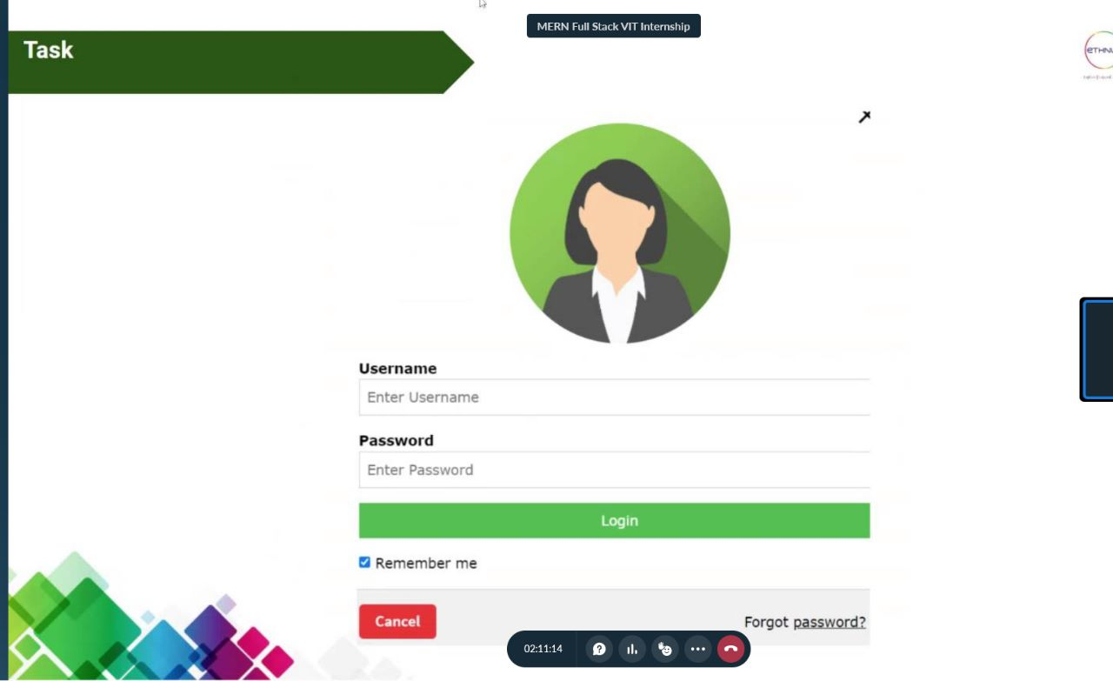

HTML code:

<html lang="en">

  <head>

    <link rel="stylesheet" href="login.css" />

    <link

      rel="stylesheet"

      href="https://cdnjs.cloudflare.com/ajax/libs/font-awesome/4.7.0/css/font-awesome.min.css"

    />

    <meta charset="UTF-8" />

    <meta http-equiv="X-UA-Compatible" content="IE=edge" />

    <meta name="viewport" content="width=device-width, initial-scale=1.0" />

    <title>Document</title>

  </head>

  <body>

    <br />Styled Page - 20BCE2096 <br /><br />

    <div class="card">

      <img src="person.jpg" alt="Person" class="circular-icon" />

      <h1>Login</h1>

      <form>

        <div class="container">

          <label for="username"><b>Username</b></label>

          <input

            type="text"

            placeholder="Enter Username"

            name="username"

            required

          />

          <label for="password"><b>Password</b></label>

          <input

            type="password"

            placeholder="Enter Password"

            name="password"

            required

          />

          <button type="submit">Login</button>

          <label>

            <input type="checkbox" checked="checked" name="remember" /> Remember

            me

          </label>

        </div>

        <button type="button" class="cancel-btn">Cancel</button>

        <a href="#" class="forgot-password">Forgot Password?</a>

      </form>

    </div>

  </body>

  <body></body>

</html>

CSS code:

\* {

  box-sizing: border-box;

}

.card {

  max-width: 450px;

  margin: 0 auto;

  text-align: center;

  padding: 40px;

  border-radius: 5px;

  background-color: #f2f2f2;

  box-shadow: 0 4px 8px 0 rgba(0, 0, 0, 0.3);

}

.circular-icon {

  width: 100%;

  border-radius: 50%;

  object-fit: cover;

*/\* border: 1px solid green; \*/*

}

.container {

  padding: 16px;

}

input[type="text"],

input[type="password"] {

  width: 100%;

  padding: 12px 20px;

  margin: 8px 0;

  display: inline-block;

  border: 1px solid #ccc;

  box-sizing: border-box;

}

button {

  background-color: #4caf50;

  color: white;

  padding: 14px 20px;

  margin: 8px 0;

  border: none;

  cursor: pointer;

  width: 100%;

}

button:hover {

  opacity: 0.8;

}

label {

  float: left;

}

input[type="checkbox"] {

  margin-top: 16px;

}

h1 {

  font-size: 24px;

}

img {

  border-radius: 50%;

}

.cancel-btn {

  background-color: #f44336;

  color: #fff;

  padding: 10px 20px;

  border: none;

  cursor: pointer;

  margin-right: 10px;

}

.forgot-password {

  color: #999;

  text-decoration: none;

}

Output:

